TEAM PROJECT REPORT
Energy Storage Devices Based on Three Dimensional (3D) Graphene:
Case Supercapacitors and Lithium- Sulfur (Li-S) Batteries
Submitted To
The RET Site
For
“Challenge-Based Learning and Engineering Design Process Enhanced Research Experiences for Middle and High School In-Service Teachers”

Sponsored By
The National Science Foundation
Grant ID No.: EC-1404766
College of Engineering and Applied Science
University of Cincinnati, Cincinnati, Ohio

Prepared by
Tiara Anderson, Pre-Algebra and Integrated Math I, Grade 9, Purcell Marian High School, Cincinnati, Ohio
Michael Sullivan, STEM, Grades 10 and 11, Princeton High School, Cincinnati, Ohio
Approved By
__________Noe Alvarez T_______________
Noe Alvarez, Ph.D.
Chemical and Materials Engineering Department
College of Engineering and Applied Sciences
University of Cincinnati

Reporting Period: June 12 - July 27, 2017

Abstract
As sustainable energy gradually replaces fossil fuel energy sources, energy storage technology needs to advance; existing lithium-ion batteries are nearing the limits of their performance and they are not able to match fossil fuels for energy density or power density. Lithium-sulfur batteries are seen as the next step in battery technology, but problems persist in achieving long-term cyclability of lithium-sulfur systems, and graphene structures are emerging as leading candidates for resolving this problem. The present research builds on existing research into the use of three-dimensional graphene as a cathode host material, and tests the impact of laser milling on lithium-sulfur battery performance. Our data indicates that laser milling produces excess carbon black on the surface of the graphene, and battery cyclability was significantly reduced in early testing.
Key Words
Amorphous carbon, energy density, graphene, intercalation/de-intercalation, gravimetric energy density, gravimetric power density, lithium-sulfur batteries, nanotechnology, polysulfide shuttling, power density, Raman spectroscopy, specific energy, and specific power.

Introduction
Society depends on reliable supplies of electricity to enable productivity, social connectivity, and entertainment (Helm 2017). Fossil fuels, though dense with both energy and power, are finite and produce waste products that add long-term costs beyond simply their harvest, delivery, and refinement (OECD 2013). Wind, water, and solar energy sources are seen as superior due to their sustainability profile (Mai 2012) but they are not available on demand. Part of the sustainable energy solution, therefore, must include energy storage so that electricity is still available even when the wind is not blowing, water is not falling, and the sun is not shining at the user’s location (Strandén et al. 2009).
Starting with simple zinc-acid batteries in the 19th Century (Thompson 1881), researchers have worked at finding materials other than fossil fuels that have relatively high energy and power densities. This pursuit led to the development of lead acid batteries and then nickel-cadmium batteries, which were in turn replaced by nickel metal hydride batteries that were subsequently replaced by lithium-ion batteries (Abruña et al. 2008). Lithium-ion batteries have enough energy density to support the development of laptop computers, smartphones, and other hand-held electronics; previous generations of batteries lacked the energy density and the energy cycling endurance that lithium-ion batteries can deliver. In addition to improving the convenience and longevity of those devices, we need better batteries to provide meaningful energy storage for vehicles, buildings, and heavy machinery. Lithium-ion batteries do not have the energy density or the power density to meet the demands currently met by fossil fuels. Energy density is a measure of how much total energy can be stored in the battery and power density is the rate at which the battery can cycle energy in and out.
To that end, researchers have been considering other battery designs. The current focus of new battery research and development has focused on lithium-sulfur (Li-S) designs. Sulfur has the advantage of having a low mass-to-volume ratio while having a high energy-to-weight ratio. An ideal Li-S battery would have five times the gravimetric energy density of an ideal lithium-ion battery. The challenge with sulfur, however, is that it is the least conductive element. To overcome its insulating properties, researchers have added carbon to the sulfur, along with a binding agent to hold the materials together. Unfortunately, the carbon and the binding agent occupy space in the battery that otherwise could be filled with sulfur, in effect reducing the energy density of the cathode. Thus, working Li-S battery designs will not be able to achieve the theoretical gravimetric energy density of the ideal Li-S battery – about 2600 Wh∙kg⁻¹ (Wu et al. 2015) – but researchers expect that it will be possible to develop Li-S batteries that easily outperform the best lithium-ion batteries on the market.
In addition to outperforming the best of today’s batteries, Li-S batteries may cost less to produce. Instead of rare and expensive metals like cobalt (commonly used in lithium-ion batteries), sulfur is abundant, non-toxic, and cheap. The final price of the Li-S battery design that is able to compete with lithium-ion batteries is unknowable, however, because researchers still have technological issues to solve, the resolution of which will add to the cost of production.
At present, three such issues remain: electrode expansion, polysulfide shuttling, and the degree to which sulfur resists electric conduction. The present project aims to address all three issues with a specially-treated graphene host intercalated with elemental sulfur. Rather than two-dimensional sheet graphene which has no capacity to host sulfur, this project involves the production of free-standing, three-dimensional graphene, a naturally-conductive structure whose mesopores are appropriately-sized for containing sulfur without causing problematic expansion of the cathode structure when lithium ions are introduced. In addition, the graphene host will undergo laser milling to increase the surface area available for the attachment of functional groups during plasma treatment, which is hoped to improve the overall wettability of the graphene and permit a more effective seal with the separator, thus minimizing polysulfide shuttling.

Literature Review

Li-S Overview
The Li-S battery has a theoretical specific capacity of 1675mAh/g, four times the capacity of the lithium ion battery (Abruña et al. 2008). The Li-S battery also has a high theoretical energy density (the amount of energy stored per unit volume) of 2600 Wh/kg (Kang et al. 2016). A comparison of the gravimetric and volumetric energy density of the lithium ion and lithium sulfur battery is provided in Figure 1. Lithium metal is known to be a suitable battery material candidate due to many inherent properties. It is the lightest metal on earth, highly reactive due to its electron configuration (one valence electron), and has a high specific capacity of 3861 mAh/g (Kang et al. 2016). Due to its low electron affinity, lithium metal generally acts as the negative electrode (anode) in a battery. Sulfur serves as the active material of the cathode in the Li-S battery. Elemental sulfur is abundant in nature, low in cost and is environmentally benign (Yin et al. 2013). Also, elemental sulfur is chemically stable. Outstanding chemical stability is attributed to its crown-like structure which is comprised of eight sulfur atoms bonded to one other in a ring (See Figure 2). High capacity and charge-discharge performances by sulfur-based cathodes are due to the breakage of the covalent bonds in the $S_{8}$ molecule (Kang et al. 2016). During the discharge process, each sulfur atom holds two electrons. This is a greater quantity compared to traditional metal cathodes, which transfer one or less than one electron per atom. More discussion of the electrochemistry driving the Li-S battery is discussed in the next section. Sulfur itself is insulating so it must be combined with a conductive material to serve as a cathode (Werner et al. 2015).

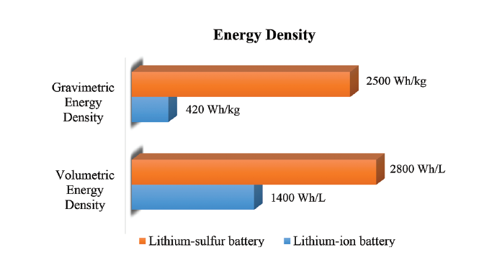
Figure 1: Energy density plots of lithium-ion vs. lithium-sulfur batteries (Seh et al. 2016)
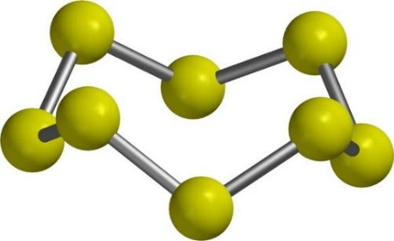
Figure 2: Crown-like structure of S₈ (Seh et al. 2016)

Li-S Mechanics (Electrochemical Process)
Since elemental sulfur is in a charged state, a newly-assembled Li-S battery starts fully charged. During discharge, each lithium atom is oxidized yielding one electron and one lithium ion per lithium atom. A pair of lithium ions and electrons react with sulfur at the cathode.
Figure 3 displays the anodic and cathodic chemical reactions for the Li-S battery. In comparison to the lithium ion battery, the transference of electrons per atom of active cathodic material in the Li-S battery is doubled which contributes to its higher specific capacity. Figure 4 shows the complete chemical reaction as lithium reacts with sulfur to produce solid Li₂S during discharge. During charge, the reaction is reversed.
Discharge: | Anodic Reaction: $Li→{Li}^{+}+e^{-}$  Cathodic Reaction: $S_{8}+16{Li}^{+}+16e^{-}→8{Li}_{2}S$
Charge: | Anodic Reaction: $8{Li}_{2}S→S_{8}+16{Li}^{+}+16e^{-}$  Cathodic Reaction: ${Li}^{+}+e^{-}→Li$

Figure 3: Li-S overall chemical reactions during discharge and charge conditions
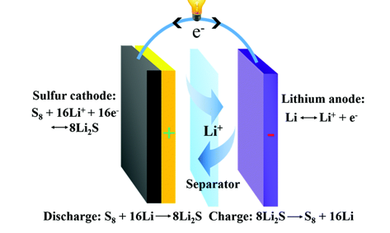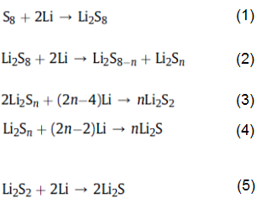
Figure 4: Li-S battery diagram and complete reaction breakdown of polysulfides (Seh et al. 2016)
As sulfur interacts with lithium ions, the reaction creates negatively-charged intermediary compounds of the form Li₂S_{n} (2 < n < 8), known as lithium polysulfide intermediates (Li-PS). Solid elemental sulfur, S_{8,} is reduced to the solid product Li₂S. Li-PS molecules, on the other hand, are soluble in electrolyte. If not trapped against the cathode, Li-PS will diffuse across the separator, discharge energy into the electrolyte where it will escape as heat rather than as harnessed electrical energy, and eventually deposit Li₂S on the anode. Over time, this reduces the available surface area of the anode, eroding the energy capacity of the battery.

Li-S Challenges
As S₈ undergoes the reaction, the formed polysulfide intermediates are in the liquid state. The high order polysulfides Li₂S_{n} (4 < n < 8) dissolve in the electrolyte, shuttle to the anode, interact with lithium, and reduce to low order polysulfides, Li₂S_{n} (2 < n < 4). Li₂S forms a barrier on the lithium anode known as solid electrolyte interface (SEI) which passivates the lithium anode surface, reducing the ability of the anode to cycle lithium ions (Zheng et al. 2013). The polysulfides may then travel back to the cathode, interact with sulfur and deposit Li₂S (solid) on the cathode. Li₂S is insoluble and does not conduct electricity, so Li₂S deposition on the anode’s surface halts electronic and ionic transfer. The rapid loss of active material and passivation of the surface of the anode and cathode directly produces low cyclability of the battery. This phenomenon is known as the “polysulfide shuttle effect.” (See Figure 5)
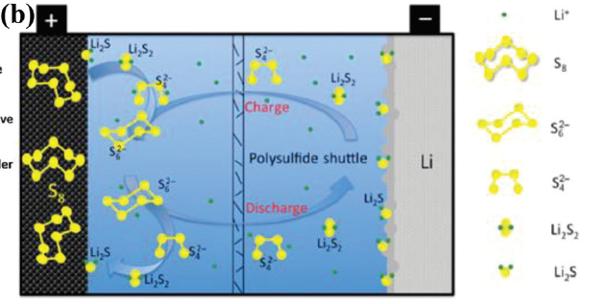
Figure 5: Polysulfide shuttle effect (Barghamadi et al. 2013)
Along with the poor conductivity of sulfur and the shuttle effect, the dramatic volume changes of the cathode during lithiation and delithiation presents another challenge facing the use of sulfur as a cathode (He et al. 2009). As the chemical reaction is underway, the cathode undergoes a volume change of as much as 80%. A cathode that can withstand volume change, mitigate the polysulfide effect and increase the conductivity of sulfur would hypothetically increase both the cycle life and columbic efficiency of the battery.

Carbon – Sulfur Cathode Composites
Carbon has emerged as a promising material to address challenges with the sulfur cathode (Zhou 2017). Carbon is highly conductive so it can increase the electrical conductivity of sulfur. Carbon is porous. Thus, a carbon host can potentially promote ionic and electronic transport, hold polysulfide intermediates to prevent dissolution in the electrolyte and act as a space buffer to withstand the changes in volume. Many researchers have turned to carbon as an inactive material to add with sulfur to create a composite cathode for the Li-S battery.
Carbon materials are classified by pore size and major morphologies. Microporous carbon has pore sizes smaller than 2nm, facilitating the accommodation and immobilization of the active material. Mesoporous carbon has pore sizes from 2nm to 50nm. The smaller pores efficiently encapsulate the sulfur and the larger pores are good for ion and electrolyte transport. Carbon with pore sizes greater than 50nm is macro-porous and is mostly used to create carbon nanotubes and carbon nanofibers. Macro-porous carbon can absorb the electrolyte and consequently mitigate polysulfide migration as the polysulfides have dissolved in the electrolyte. Various carbon materials, including microporous, mesoporous, hierarchical porous carbon, carbon black, hollow carbon spheres, carbon nanotubes, carbon nanofibers, and graphene have been used to form sulfur-carbon composites. Research has proven that carbon materials can effectively contain the active material (sulfur), trap polysulfides, aid in electronic and ionic transport and absorb or channel electrolyte (Manthiram et al. 2014).
Microporous carbon as a host can immobilize sulfur. Zhang et al. introduced sulfur to the center of microporous carbon sphere using a two-step heat treatment process. The chemical reaction took place inside of the pores and achieved a specific capacity of 650mAh/g for 500 cycles (Manthiram et al. 2014). Yin et al. achieved a specific capacity of 1149mAh/g after 200 cycles by using the micropores to trap the low order polysulfides to decrease the transition to higher order polysulfides which are more readily dissolvable in the electrolyte (Manthiram et al. 2014). Mesoporous carbon has a combination of small, midsized and large pores that can make the material advantageous as a host. Lin et. al. reported pore sizes of 22nm with 50 wt% sulfur loading filling the pores (Lin et al. 2014). With this composite, they achieved an initial specific capacity of 1390mAh/g but could only retain a specific capacity of 840mAh/g after 100 cycles. Other researchers have used graphene oxide nanosheets – combined with napthalimide-functionalized poly(amidoamine) dendrimers – to create a barrier that permits free passage of lithium ions but not polysulfide intermediates, effectively preventing deposition of Li₂S on the anode (Liu et al. 2017). Out of concern that such a barrier would also slow the movement of lithium ions, other researchers have advocated for approaches that involve holding the polysulfides against the cathode – surface chemistry initiated strategies (Hou et al. 2017).
Graphene has emerged as the most effective carbon material to be used in the sulfur cathode. Graphene is an allotrope of carbon with a 2D hexagonal structure. It is ultralight, ultrathin, hard yet flexible, and is highly conductive. Because graphene materials are mechanically stable even at single-atom thicknesses, researchers have favored graphene as the basic building block for carbon materials with varying dimensionalities including 0D fullerene spheres, 1D nanotubes, 2D graphene sheets, and 3D graphite (Geim and Novoselov 2007). In the present research, a nickel-polymer substrate has been used to produce free-standing graphene (3D graphene), providing a combination of the attributes of 3D graphite with 2D graphene, as discussed later in this paper.

Cathode Composite Synthesis Methods
The method used for assembling the cathode in a Li-S battery will affect both energy density and cyclability. As such, there have been multiple approaches as researchers seeks to optimize battery structures. Researchers must choose how sulfur will be combined with the carbon material, how the current collector will be added, and how the cathode will interface with the separator.

Methods to Introduce Sulfur to Carbon Network
Although a suitable carbon network will ensure increased conductivity of the cathode in an Li-S battery, it is also important to ensure there is a strong, intimate connection between that network and the sulfur (Manthiram et al. 2014). There must be an intimate bond between the carbon host and the active material to prevent loss of active material to the electrolyte where the current collector is unable to transmit discharged energy out of the system. Both the type of carbon and the process in which it is introduced to sulfur are vital to creating an effective composite material as a cathode. Successful encapsulation of the sulfur in the host is imperative to good sulfur utilization in the cathode. Three synthesis methods have been used to combine the active and inactive material in the sulfur composite. It is important to note that for many composites conductive additives and binder are added in addition to sulfur and carbon to create the cathode (Borchardt et al. 2016). The consequence of such a strategy, however, is that in a battery cell of finite volume, space taken up by additives and binders is space that cannot be filled with sulfur, thereby reducing the energy density of the assembled battery.
Another synthesis method is a two-step heat treatment that seeks to impregnate the sulfur in the carbon host to create effective encapsulation. In the first step the sulfur is melted, lowering its viscosity so that it can seep into the pores of the carbon host. In the second step, the composite is heated to a higher temperature to vaporize sulfur that remains on the surface of the composite. The heating method is widely used a preparation technique for the S-C composite (Wang et al. 2011). In 2009, Jiang et al. revised this method by finding the optimal temperature for yielding the lowest viscosity for sulfur. At 155ºC, sulfur is at its lowest possible viscosity and will achieve peak penetration of the carbon host. This approach eliminates the need for the second step of sulfur vaporization (Jiang et al. 2015).

Conventional Cathode Synthesis Method
Most Li-S batteries are fabricated by casting a slurry onto a current collector such as aluminum foil. The slurry contains the active materials, binder, conductive additives and an organic solvent. This structured is then dried at a certain temperature for a certain number of hours depending on the organic solvents used. This conventional way of producing the sulfur composite faces a number of limitations. First, the conventional method is complex and time consuming as it involves three intricate, delicate processes: 1) creating a homogeneous mixture of the components, 2) casting and pressing the slurry onto the current collector, and 3) drying the cathode at the optimal temperature and time length. Also, depending on the organic solvent used, the cathode may take up to 12 hours to dry completely (Hameed 2016). Second, the addition of polymer binder decreases the ability for electrons to transfer freely, reducing the conductivity of the material. Third, the aluminum foil current collector adds a substantial amount of (inactive) weight to the cathode. Since the specific capacity is calculated as milliampere hours per gram, any increase in weight reduces the capacity of the battery. Fourth, aluminum metal oxidizes and corrodes at high operating voltages of the sulfur cathode (Whitehead and Schreiber 2005).

Advantages to NanoWorld Laboratories Cathode Synthesis Method
Researchers at NanoWorld laboratories at the University of Cincinnati have developed a seamless method to create freestanding, three-dimensional (free-standing) graphene to be used as the carbon host for sulfur in the cathode. This structure addresses the challenges with the conventional methods of cathode preparation. Since the synthesized graphene is free standing and three dimensional, it does not require the support of an external structure, as the aluminum foil provided in the conventional method. This decreases the density of the cathode, which in turns increases the specific capacity. Graphene is highly conductive, so there is no need for conductive additives or a separate current collector. NanoWorld synthesizes 3D graphene using chemical vapor deposition, producing a free-standing graphene structure that can then be used in the cathode assembly.

GOALS AND OBJECTIVES
In an attempt to address Li-S battery performance issues caused by the low native wettability of three-dimensional graphene (3DG), this project added a process: laser milling. Parallel research efforts at NanoWorld focused on graphene-structured supercapacitors (see Appendix III on page 18) showed that laser milling 3DG improved supercapacitor performance. The current research project sought to leverage that finding by adding laser milling to the preparation of a 3DG cathode for use in a Li-S battery. Data suggested that doing so would increase both surface area and disorder of the graphene surface, improving wettability and allowing for additional functional groups to attach during plasma treatment (which would, in turn, further improve wettability).

RESEARCH STUDY DETAILS

Production of free-standing 3D graphene
A slurry of nickel powder, ethanol, and a plasticizer was cast into a thin sheet of non-brittle nickel that could then be cut into strips. Nickel particles within the strip were reduced under H₂ and sintered to create a porous scaffold that when combined with methane in a tube furnace and heated to 1000ºC for 5 minutes, act as a catalyst and substrate for the chemical vapor deposition (CVD) of graphene as the methane breaks apart and carbon soot coats the nickel surface, filling in the gaps left by the vaporization of the plasticizer in the nickel.
The graphene-coated nickel strip (3DG-Ni) was then soaked in HCl for 15 hours to ensure that all of the nickel was dissolved, leaving pristine graphene in a three-dimensional structure (3DG). Remnants of solution were removed by soaking the 3DG in deionized water, removing it, and soaking it in a fresh dish of deionized water.

Laser milling of 3DG
Once dry, the 3DG was placed in a laser mill and shallow grooves were cut in rows across its surface, resulting in L3DG. Five-point (1D) Raman spectroscopy before and after milling confirmed that the process caused significant disordering of the graphene.

Plasma treatment of L3DG
The L3DG was exposed to plasma while being sprayed with an air mixture that was 98% Ar and 2% O₂ by volume. Due to the presence of H₂O from ambient humidity, functional groups (primarily carbonyls and lone oxygen atoms) bonded to the laser-milled surface of the graphene, resulting in LO3DG. Raman spectroscopy confirmed that this treatment caused additional disordering of the graphene.

Sulfuration of LO3DG
After oxygen functionalization, the LO3DG was placed in an autoclave along with elemental sulfur (S₈) and ethanol. The combination was heated at 156°C for 15 hours; at this temperature, S₈ is liquid and its viscosity is minimized, allowing for thorough penetration of the LO3DG. Upon removal from the autoclave, the LO3DG-S was rinsed with a carbon sulfide solution to remove surface clusters of sulfur while preserving the intercalated sulfur. This was done to ensure that only intercalated sulfur would be present in the cathode, thus minimizing the amount of sulfur that might contribute to dissolved polysulfides in the electrolyte and degrade battery performance over time through shuttling.

Assembly of Sulfur Cathode
The laser mill cut LO3DG-S into six disks, each 12mm in diameter. Cathode coin battery caps were each loaded with a stainless steel spring, a stainless steel spacer, a disk of LO3DG-S soaked in electrolyte, and a plasma-treated polymer separator. The functional groups on both the LO3DG-S and the separator are assumed to improve the contact between those two surfaces and further reduce the ability of sulfur to escape the cathode during discharge operation.

Assembly of the Coin Battery
A hyperbaric glove box filled with Ar gas was used for final assembly of the coin batteries. A disk of Li metal was placed atop the separator in the cathode cap, then a stainless steel spacer was placed on the Li metal disk, then the anode cap was used to close off the battery. This completed assembly was then put into a hydraulic crimper and sealed. Six batteries were assembled in this way.

RESEARCH RESULTS
Battery performance was tested in batches of batteries over the course of four weeks, with the totals of each battery type averaged to address variability between batteries. As can be seen in Figure 6, Coulombic efficiency was at or near 100% for all three cathode types, but discharge capacity can be seen to differ significantly between the cathode types. Specifically, the unprocessed 3DG-S battery was unable to retain more than 1000 mAh/g of capacity after the first dozen cycles. Both the O3DG-S (plasma functionalized) and LO3DG-S (laser milled and plasma functionalized) initially demonstrated a capacity over 1200 mAh/g, but the battery with laser milled graphene lost capacity at more than four times the rate at which the O3DG-S battery lost capacity.
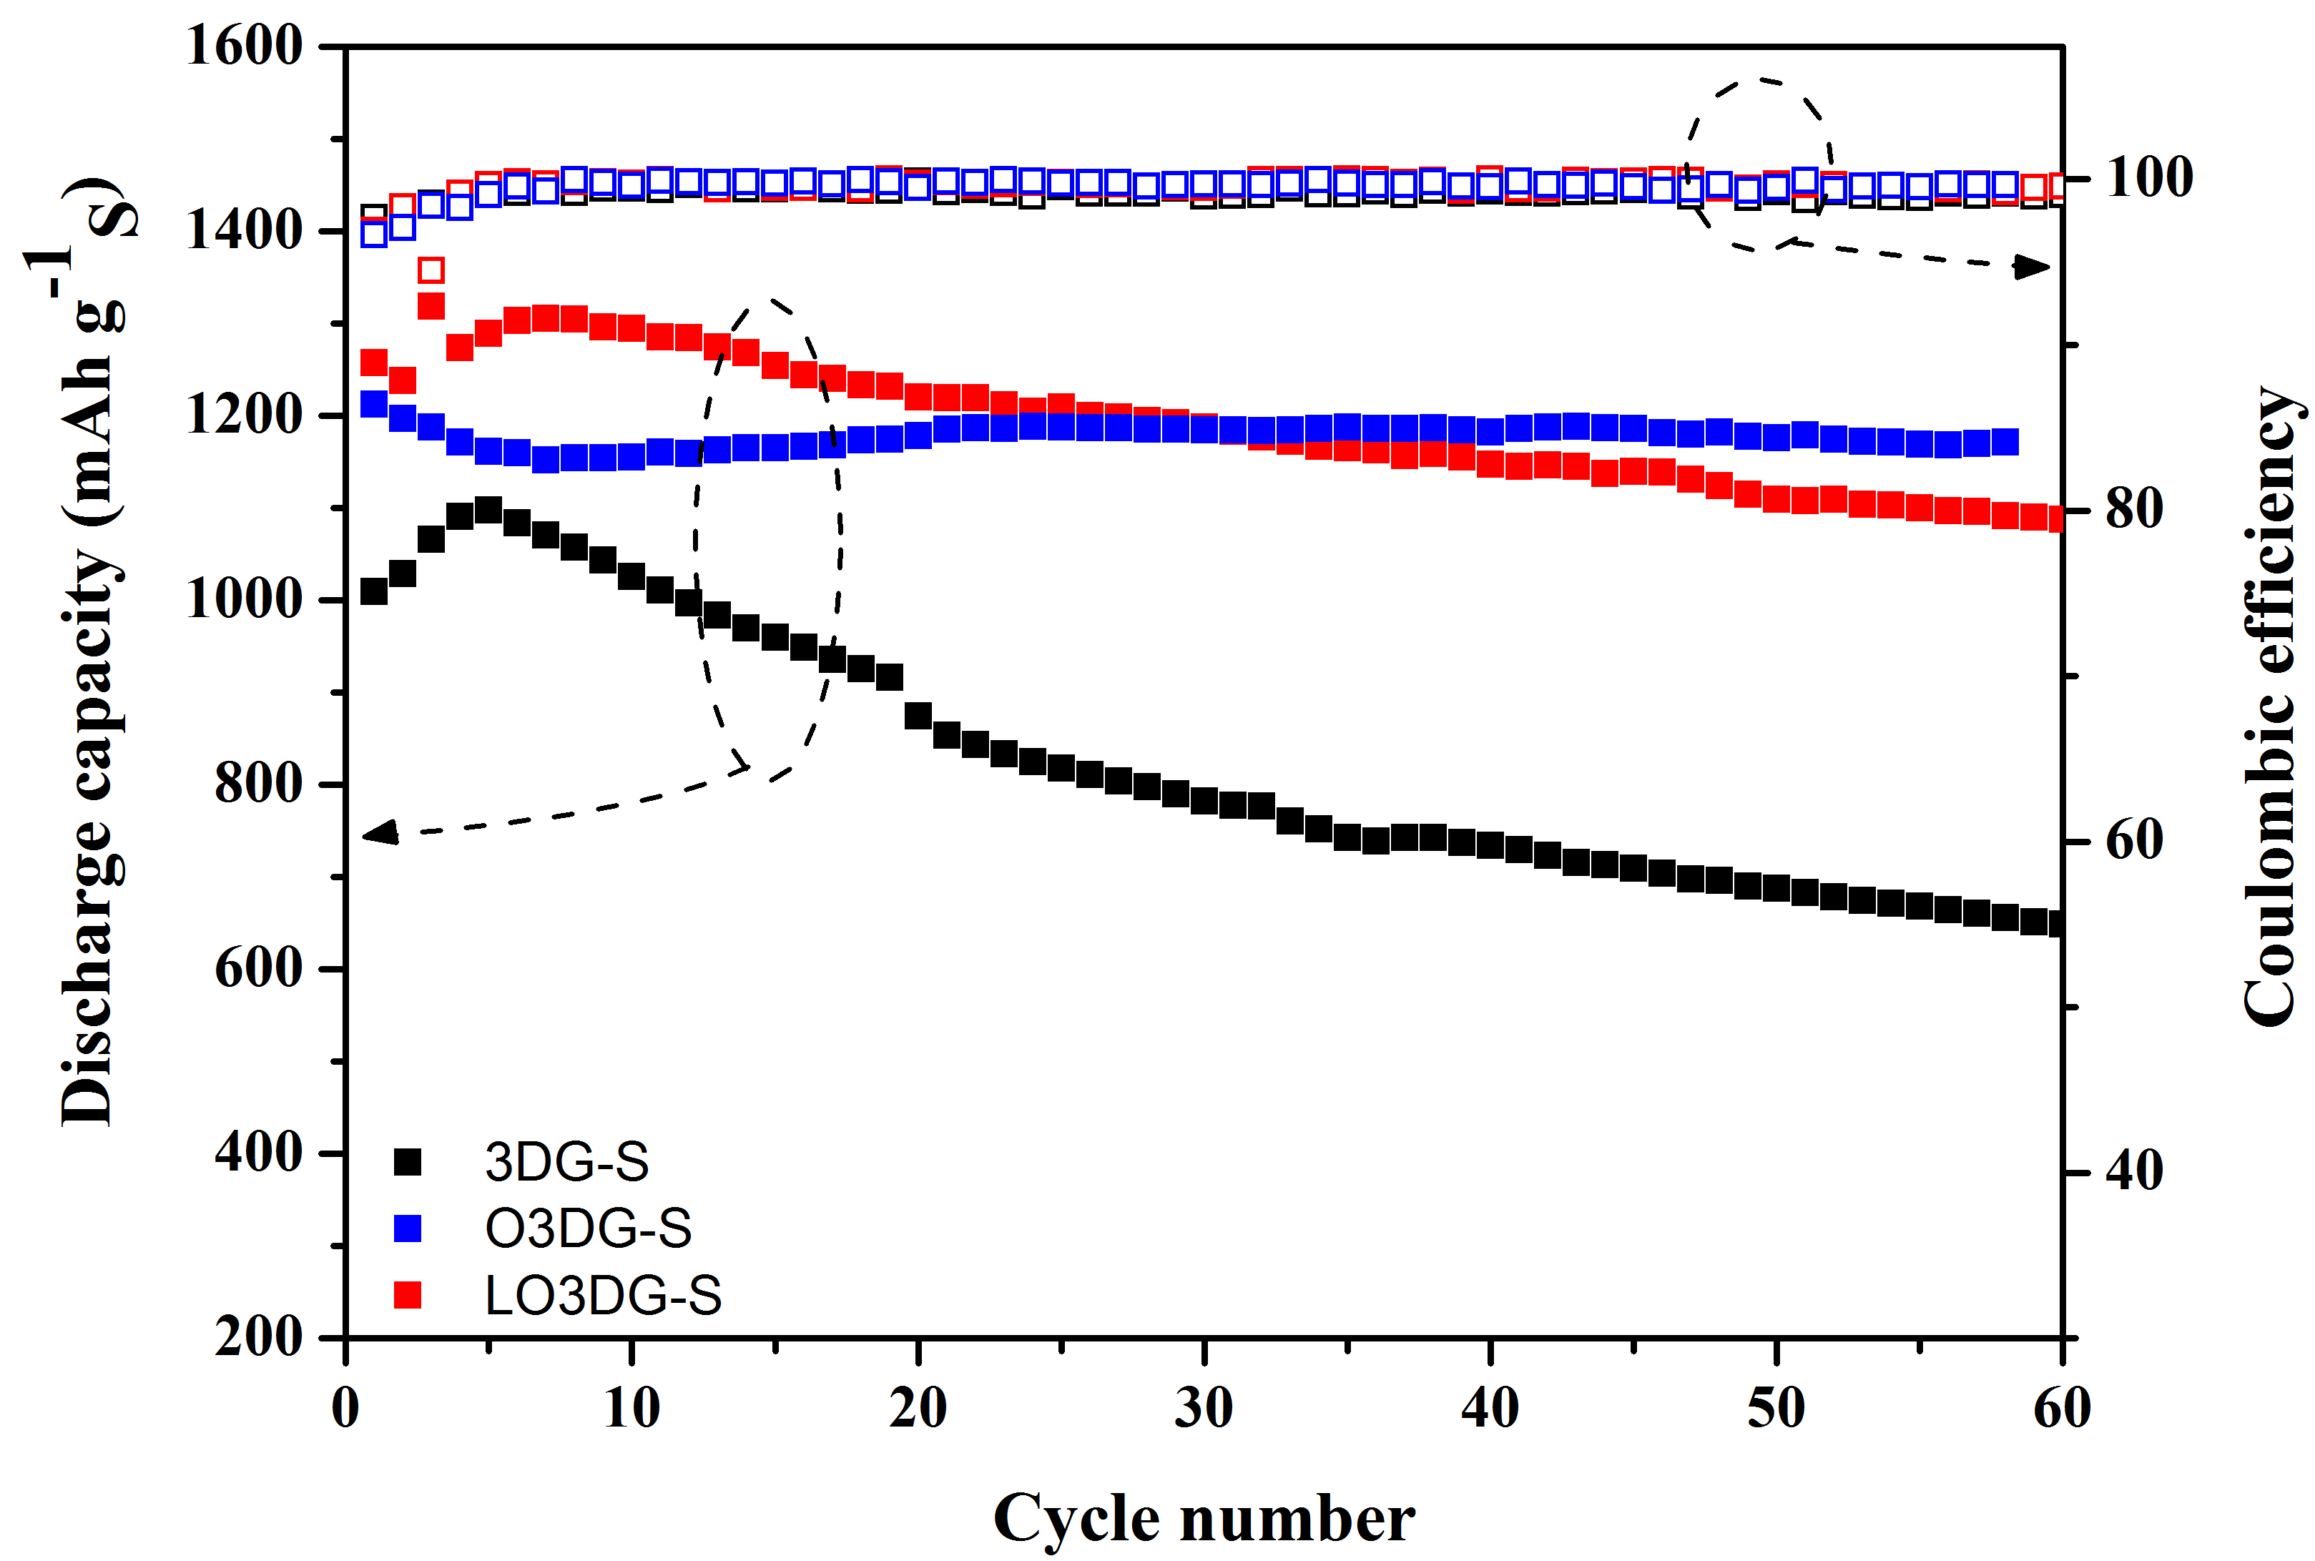
Figure 6: Data collected through 58 cycles of the test batteries, alongside control data from batteries that relied on cathodes that lacked laser milling (O3DG-S) and cathodes that lacked either laser milling or plasma treatment (3DG-S)
A scanning electron microscope was used to view the surface of O3DG and LO3DG at various magnifications. Figures 7 and 8 display O3DG and LO3DG respectfully with a magnification of 200. The “grooves” created by laser milling can be observed in figure 8. At a higher magnification of 5,000, deposition is observed on the surface of the graphene after laser milling in figure 10.

Figure 7: SEM (scanning electron microscope) image of pristine graphene with plasma (O3DG) at 200X magnification | Figure 8: SEM (scanning electron microscope) image of plasma treated graphene with laser milling (LO3DG) at 200X magnification
Figure 9: SEM image plasma treated graphene(O3DG) at 5000X magnification | Figure 10: SEM image plasma treated graphene with laser milling (LO3DG) at 5000X magnification

CONCLUSIONS
Based on the research, laser milling does not appear to improve battery performance over time. There is a significant improvement in initial charge capacity, but over time there appears to be evidence of polysulfide shuttling in the LO3DG-S batteries that is not seen in the O3DG-S batteries that were used as a control for this experiment. It is possible that laser milling produced amorphous carbon across the milled surface of the 3D graphene. If so, it would appear that the amorphous carbon was able to retain some elemental sulfur during the carbon sulfide rinse but was not able to retain that sulfur over the course of discharge and charge cycles.
The next step is to confirm the extent to which amorphous carbon is generated during laser milling. To that end, samples have been sent to an external laboratory with access to a 2D Raman spectroscope. Raman spectroscopy should be able to definitively describe the morphology of the LO3DG in comparison to O3DG.

RECOMMENDATIONS
Other researchers are looking into the use of solid and gelled polymer electrolytes (Zhu et al. 2015), and that would be a viable next step in this case as well. In addition, it is important to establish what effect on capacity or cyclability is experienced with Li-S batteries that have multiple layers of O3DG-S in the cathode. Energy density should remain stable, but Coulombic efficiency might be negatively affected while energy capacity should increase up to the point where lithium ions become the limiting reagent.
Although lithium-air batteries promise an energy density more than four times greater than even Li-S batteries (Wu et al. 2015), researchers have not developed an effective way to prevent permanent oxidation of the anode, reducing the effective cycle life of these battery designs to a single use case. For that reason, it is the view of this laboratory that Li-S remains the most promising platform for energy storage in the near term.

CLASSROOM IMPLEMENTATION PLAN
Tiara Anderson plans to engage her ninth grade Integrated Math I students by introducing conservation of electrical energy as the big idea. To begin, students must understand why energy conservation is important. They will explore the global need to conserve energy in order to reduce reliance on fossil fuel, a limited and depleting energy source. Students will particularly focus on electrical energy understanding most electricity comes from coal. After grasping the big idea, Tiara will lead her students to form the following essential question, “how can math be used to conserve electrical energy and reduce the use of fossil fuel?” They will then complete the following challenge: Use mathematical evidence to crease and support three strategies the student population can use to conserve cell phone battery life. The challenge will encourage possible guiding questions, and investigate the answers to these questions using mathematical models and tools. To begin, students will create and conduct an all school survey to gather information about cell phone usage. Students will analyze the data and create two-way frequency tables to compare the relationship between two quantities. Students will use this information to brainstorm strategies, test them by collecting data points with their own phone and refine them. Tiara will introduce linear and exponential regression models as a mathematical tool students can use to make predictions, draw conclusions and support the strategies they have selected. Students will submit their findings in a written report, and then communicate their strategies to the student population in a create format. These may include but are not limited to a commercial, brochure, presentation, or webpage. At the conclusion of the unit, students will hopefully embrace the responsibility to be a conscious energy consumer.

Michael Sullivan plans to present his 11th grade STEM students with the idea that access to electricity is a worldwide problem that merits their attention. They will develop a challenge directly related to the big idea of access to electricity, with the expectation that they will rally around the challenge of designing and building some kind of small electrical generator. They will have access to small electrical motors that they will have to use as dynamos in a design that will involve conversion of mechanical energy into electrical energy. They will make use of 3D printers to fabricate a fitting whose core shape will be based on the spindle of the motor but whose exterior shape will be determined by the type of mechanical energy each team’s prototype is designed to capture. They will then fabricate the rest of the components necessary for capturing their choice of mechanical energy (e.g., hand cranking, foot-pedaling, wind capture, rope-pulling, or wheel spinning). Upon testing their prototype, recording its performance, and analyzing the resulting data, the students will then identify some aspect of the design that should benefit from a re-design, iteratively repeating the engineering design process for a second build that will, hopefully, outperform their initial attempt. They will communicate their results through the production of a brief Kickstarter-style video showcasing their design choices and citing Ohm’s law as well as mechanical advantage to explain how their device works.

ACKNOWLEDGEMENTS
The National Science Foundation supported this work through a grant (EC-1404766), “Challenge-Based Learning and Engineering Design Process Enhanced Research Experiences for Middle and High School In-Service Teachers.”

BIBLIOGRAPHY
Abruña, H. D., Yassuyuki, K., and Henderson, J. C. (2008). “Batteries and electrochemical capacitors.” Physics Today.
Barghamadi, M., Kapoor, A., and Wen, C. (2013). “A Review on Li-S Batteries as a High Efficiency Rechargeable Lithium Battery.” Journal of the Electrochemical Society, 160(8), A1256–A1263.
Borchardt, L., Oschatz, M., and Kaskel, S. (2016). “Carbon Materials for Lithium Sulfur Batteries - Ten Critical Questions.” Chemistry - A European Journal, 22(22), 7324–7351.
Geim, A. K., and Novoselov, K. S. (2007). “The rise of graphene.” Nature Materials, 6(3), 183–191.
Hameed, A. S. (2016). Phosphate Based Cathodes and Reduced Graphene Oxide Composite Anodes for Energy Storage Applications. Springer Theses, Springer-Verlag.
He, X., Ren, J., Wang, L., Pu, W., Jiang, C., and Wan, C. (2009). “Expansion and shrinkage of the sulfur composite electrode in rechargeable lithium batteries.” Journal of Power Sources, 190(1), 154–156.
Helm, D. (2017). Burn out: the endgame for fossil fuels. Yale University Press.
Hou, T.-Z., Xu, W.-T., Chen, X., Peng, H.-J., Huang, J.-Q., and Zhang, Q. (2017). “Lithium Bond Chemistry in Lithium-Sulfur Batteries.” Angewandte Chemie International Edition, 94720, 8178–8182.
Jiang, Y., Lu, M., Ling, X., Jiao, Z., Chen, L., Chen, L., Hu, P., and Zhao, B. (2015). “One-step hydrothermal synthesis of three-dimensional porous graphene aerogels / sulfur nanocrystals for lithium – sulfur batteries.” JOURNAL OF ALLOYS AND COMPOUNDS, Elsevier B.V., 645, 509–516.
Kang, W., Deng, N., Ju, J., Li, Q., Wu, D., Ma, X., Li, L., Naebe, M., and Cheng, B. (2016). “A review of recent developments in rechargeable lithium–sulfur batteries.” Nanoscale, Royal Society of Chemistry, 8(37), 16541–16588.
Lin, J., Peng, Z., Liu, Y., Ruiz-Zepeda, F., Ye, R., Samuel, E. L. G., Yacaman, M. J., Yakobson, B. I., and Tour, J. M. (2014). “Laser-induced porous graphene films from commercial polymers.” Nature Communications, Nature Publishing Group, 5, 5714.
Liu, W., Jiang, J., Yang, K. R., Mi, Y., Kumaravadivel, P., Zhong, Y., Fan, Q., Weng, Z., Wu, Z., Cha, J. J., Zhou, H., Batista, V. S., Brudvig, G. W., and Wang, H. (2017). “Ultrathin dendrimer–graphene oxide composite film for stable cycling lithium–sulfur batteries.” Proceedings of the National Academy of Sciences, 114(14), 3578–3583.
Mai, T. (2012). Renewable Electricity Futures.
Manthiram, A., Fu, Y., Chung, S., Zu, C., and Su, Y. (2014). “Rechargeable Lithium − Sulfur Batteries.” Chemical Reviews, 114, 11751–87.
OECD. (2013). Inventory of Estimated Budgetary Support and Tax Austria. OECD Publishing.
Seh, Z. W., Sun, Y., Zhang, Q., and Cui, Y. (2016). “Designing high-energy lithium–sulfur batteries.” Chem. Soc. Rev., 45(20), 5605–5634.
Strandén, J., Nurmi, V.-P., Verho, P., and Marttila, M. (2009). “State of preparedness of Finnish society for major disturbances in distribution of electricity.” International Review of Electrical Engineering, 4(2), 211–219.
Thompson, S. A. (1881). “Storage_of_electricity_1881.pdf.” Journal of the Society of Arts, 1–21.
Wang, J. Z., Lu, L., Choucair, M., Stride, J. A., Xu, X., and Liu, H. K. (2011). “Sulfur-graphene composite for rechargeable lithium batteries.” Journal of Power Sources, 196(16), 7030–7034.
Werner, J. G., Johnson, S. S., Vijay, V., and Wiesner, U. (2015). “Carbon-sulfur composites from cylindrical and gyroidal mesoporous carbons with tunable properties in lithium-sulfur batteries.” Chemistry of Materials, 27(9), 3349–3357.
Whitehead, A. H., and Schreiber, M. (2005). “Current Collectors for Positive Electrodes of Lithium-Based Batteries.” Journal of The Electrochemical Society, 152(11), A2105.
Wu, Y., Yuan, X., Zhao, S., and van Ree, T. (2015). Lithium-ion Batteries. Lithium-ion Batteries, CRC Press.
Yin, Y. X., Xin, S., Guo, Y. G., and Wan, L. J. (2013). “Lithium-sulfur batteries: Electrochemistry, materials, and prospects.” Angewandte Chemie - International Edition, 52(50), 13186–13200.
Zheng, J., Gu, M., Chen, H., Meduri, P., Engelhard, M. H., Zhang, J.-G., Liu, J., and Xiao, J. (2013). “Ionic liquid-enhanced solid state electrolyte interface (SEI) for lithium–sulfur batteries.” Journal of Materials Chemistry A, 1(29), 8464.
Zhou, G. (2017). “Design, fabrication and electrochemical performance of nanostructured carbon based materials for high-energy lithium-sulfur batteries: next-generation high performance lithium-sulfur batteries.” Springer Theses, Chinese Academy of Sciences.
Zhu, Y., Xiao, S., Wu, Y., and van Ree, T. (2015). “Solid Electrolytes.” Lithium-ion Batteries, Y. Wu, ed., CRC Press, 341–397.

APPENDIX I: NOMENCLATURE USED
2D_{peak} = as viewed through a Raman spectroscope, the ratio of its magnitude when compared to the G_{peak} value for a crystal will provide insight as to the thickness of the structure,
D_{peak} = extent of disorder of a crystalline structure, as viewed through a Raman spectroscope, and
G_{peak} = peak gamma value; used to identify the material being viewed through a Raman spectroscope.

APPENDIX II: RESEARCH SCHEDULE
June 19: Tube furnace training; plasma treatment training; laser mill training.
June 20: Autoclave/air oven training; scanning electron microscopy (SEM) training, Raman spectroscopy training; thermographic analysis (TGA) training.
June 21: Use of tube furnace to synthesize three-dimensional graphene around nickel substrate (3DG-Ni); use of HCl bath to dissolve nickel and leave pristine 3DG.
June 22: Use of Raman spectroscopy to confirm morphology and disorder level of 3DG; use of SEM to confirm presence of mesopores in 3DG; use of laser mill to cut grooves into surface of 3DG to produce L3DG; use of Raman spectroscopy to confirm change in disorder of graphene; use of plasma treatment to add carbonyl and oxygen functional groups to produce OL3DG; use of autoclave and air oven to sulfurate the graphene and produce OL3DG-S.
June 23: Use of Raman spectroscopy to confirm change in disorder level of graphene; use of SEM to confirm intercalation of sulfur in OL3DG-S; rinsing of OL3DG-S in CS solution to remove excess sulfur that did not intercalate into the graphene.
June 26: Use of TGA to confirm weight ratio of sulfur to graphene in OL3DG-S.
June 27: Origin data analysis software training; use of Origin to analyze data obtained from SEM, Raman spectroscopy, and TGA.
June 28: Hyperbaric glove box and crimper training; use of laser mill to cut 12mm disks from OL3DG-S.
June 29: Battery assembly training, using the glove box and crimper.
June 30: Battery tester training; use of battery tester to initiate cycling tests on assembled batteries.
July 3: Use of battery tester to collect preliminary data; analysis of preliminary data and discussion of implications.
July 5: Use of tube furnace to synthesize second batch of 3DG.
July 6: Use of laser mill, plasma treatment, and autoclave to prepare 3DG for use as cathode material.
July 7: Use of SEM and Raman spectroscope to conduct quality control of 3DG.
July 10: Use of TGA to determine weight ratio of sulfur to graphene in cathode material; use of glove box and crimper to assemble Li-S batteries.
July 11: Conclude initial test of Li-S batteries by removing batteries from tester; place second set of batteries in tester and initiate cycle testing.
July 12: Analyze final data from initial test of Li-S batteries.

APPENDIX III: PARALLEL RESEARCH – SUPERCAPACITORS
Unlike Li-S and other battery technologies – which rely on redox reactions to drive current – supercapacitors rely on electrostatic processes to facilitate high power density. Because supercapacitors are unable to store energy in chemical bonds, there are limits on energy density. Researchers working on supercapacitors and batteries are both looking into ways that carbon can improve device performance, and related (but unpublished) experimentation with graphene for use in supercapacitors demonstrated that laser milling prior to plasma treatment improved functionalization of the graphene and, ultimately, performance of the supercapacitor. The present research effort was inspired by this discovery.

APPENDIX IV: TIARA ANDERSON’S UNIT PLAN
Name: Tiara Anderson | Contact Info: andersontiara3@gmail.com | Date: December 2017

Unit Number and Title: Unit 5 – Statistical Analysis

Grade Level: | 9th
Subject Area: | Integrated Math I

Total Estimated Duration of Entire Unit: | 13 days

Part 1: Designing the Unit

Unit Academic Standards (Identify which standards: NGSS, ONLS and/or CCSS. Cut and paste from NGSS, ONLS and/or CCSS and be sure to include letter and/or number identifiers.):
Ohio’s Learning Standards for Mathematics:
- F.IF.6 Calculate and interpret the average rate of change of a function (presented symbolically or as a table) over a specified interval. Estimate the rate of change from a graph.
- F.LE.5 Interpret the parameters in a linear or exponential function in terms of a context.
- S.ID.5 Summarize categorical data for two categories in two-way frequency tables. Interpret relative frequencies in the context of the data (including joint, marginal, and conditional relative frequencies). Recognize possible associations and trends in the data.
- S.ID.6 Represent data on two quantitative variables on a scatter plot, and describe how the variables are related.
a. Fit a function to the data; use functions fitted to data to solve problems in the context of the data. Use given functions, or choose a function suggested by the context. Emphasize linear, quadratic, and exponential models. (A2, M3)
b. Informally assess the fit of a function by discussing residuals. (A2, M3)
c. Fit a linear function for a scatterplot that suggests a linear association. (A1, M1)
- S.ID.7 Interpret the slope (rate of change) and the intercept (constant term) of a linear model in the context of the data
- S.ID.8 Compute (using technology) and interpret the correlation coefficient of a linear fit.

Unit Summary
The Big Idea (including global relevance):
BIG IDEA: Conservation of Electrical Energy
Electricity is generated from coal as the source of chemical energy storage. Coal, along with other fossil fuels are of limited supply and the demand for the reliable energy they provide is high and increasing. We all have the responsibility to be conscious consumers of non-renewable energy. We can do this by being mindful of our electrical energy use and finding practical ways to conserve it.

The (anticipated) Essential Questions: List 3 or more questions your students are likely to generate on their own. (Highlight in yellow the one selected to define the Challenge):
- How can we use math to conserve electric energy and reduce the use of fossil fuel?
- What strategies can be used to reduce the waste of electric energy?
- How can we use math to monitor electric energy consumption?

Unit Context
Justification for Selection of Content – Check all that apply:
☒ Students previously scored poorly on standardized tests, end-of term test or any other test given in the school or district on this content.
☒ Misconceptions regarding this content are prevalent.
☒ Content is suited well for teaching via CBL and EDP pedagogies.
☐ The selected content follows the pacing guide for when this content is scheduled to be taught during the school year. (Unit 1 covers atomic structure because it is taught in October when I should be conducting my first unit.)
☐ Other reason(s) _____________________________________________________________

The Hook
- Watch YouTube Video: “What will happen when the oil runs out?”
https://www.youtube.com/watch?v=A7imyDSHtV0
- Write one sentence to describe the message this video is trying to convey.
- Ask more probing questions:
  - What two quantities are being compared on the x and y axis? Notice the units.
  - What happened at the peak of the graph?
  - What does the end of fuel mean for our way of life as we know it?
- Review statistics on fossil fuel consumption (PowerPoint Presentation).
- Lead students to make the connection that fossil fuel power plants provide our access to electricity… Essential Question: What can we do to be better consumers of electricity?
- After students have chosen essential question, introduce challenge with the following video:
https://www.youtube.com/watch?v=P2w8s_9Kbso
- Allow students to share times when their phone lost power at the most inopportune time.

The Challenge and Constraints:
☐ Product or ☒ Process (Check one)
Description of Challenge  (Either Product or Process is clearly explained below): | List the Constraints Applied
Challenge: Use mathematical evidence to develop and support three strategies to conserve phone battery life using a specified template  Explanation: Students will investigate the various ways to conserve battery life while having full functionality of their cell phones. They may explore leaving the phone on low power or shutting the phone off during times of non-usage. The explorations will be guided by a school wide survey created and implemented by the students. They will also investigate the effects on battery life when using various functions on the phone (such as Youtube, SnapChat, a phone call, sending a text, etc) by collecting data points and analyzing trends using linear and exponential regression. Students will use these observations to develop “best practices” or strategies to conserve phone battery life and will communicate them to their peers. | - Time  - Each strategy must be supported with mathematical data/evidence gathered by the students (linear and exponential regression models)  - Each strategy must involve use of an application or function of the phone (For example, a tip cannot be “don’t use your phone” as it is the most obvious way to conserve battery life)

Anticipated Guiding Questions (that apply to the Challenge and may change with student input.):
- How does “low power mode” conserve phone battery life?
- Which applications on the phone use the most battery life?
- Which applications on the phone use the least battery life?
- How can we track the loss of battery life over time?
- How effective is charging the battery while using it? (Extension: System of Equations)
- Is there an “optimal battery percentage” time to use high draining applications?
- What is the relationship between battery percentage, time and the application used?
- What applications on the phone does the student population use the most?
- Which cell phone brand conserves battery life the best: iPhone or Android?
- Is there an optimal battery percentage time to charge your phone?
- Is it best to allow your cell phone to charge without using it?
- What mathematical models can we use to predict how long a battery will last?

4. EDP: Use the diagram below to help you complete this section.
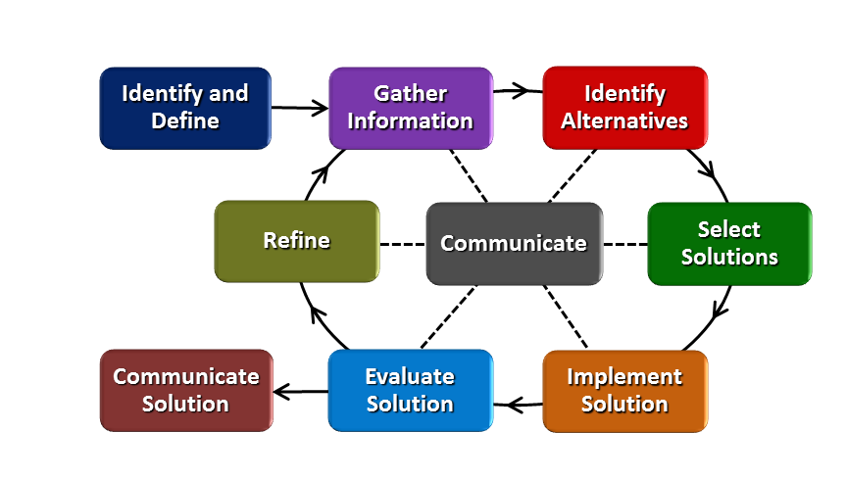
How will students test or implement the solution? What is the evidence that the solution worked? Describe how the iterative process from the EDP applies to your Challenge.
How will students test or implement the solution?
Students will implement their solution with their own devices within their team, and use these as a standard to produce data points that to be used generally. With the understanding that cell phones vary in brand, the length the battery has been in use, the number of charge and discharge cycles, etc. it may be difficult to give strategies that may be generalized.

What is the evidence that the solution worked?
For each phone battery conservation strategy, students will provide mathematical evidence to support their reasoning as required of the challenge. Furthermore, a group of at least ten other students will implement the strategies and offer feedback on how the strategies worked. Students will offer their tips along with mathematical evidence to support them. A sample group of students will try the various tips and then offer feedback or judge which tips were most effective. At least ten students must try the tips and log their responses.

How will students present or defend the solution? Describe if any formal training or resource guides will be provided to the students for best practices (e.g., poster, flyer, video, advertisement, etc.) used to present work.
Students will have the opportunity to present their strategies in a variety of ways which may include a video, poster, brochure or flyer. These will be disseminated to my other classes. Groups of 10 students outside of the class will try the various strategies for three consecutive days and log reflections daily. The reflections would include which strategies were used, how they worked, any discrepancies noticed.
There will be formal training in Excel which will be used to organize collected data through Google Forms, calculate linear and exponential regression using data points, and to create formal graphs.
What academic content is being taught through this Challenge?
- Analyzing data
- Finding the line of best fit (linear and exponential regression)
- Developing a statistical survey and analyzing the data collected to draw conclusions
- Using linear and exponential functions to make future and past predictions
- Drawing conclusions from two-way frequency tables

Using the diagram above, identify any places in the EDP where assessments should take place, as it applies to your Challenge. Describe below what kinds of assessment are most appropriate.

What EDP Processes are ideal for conducting an Assessment?  (List ones that apply.) | List the type of Assessment  (Rubric, Diagram, Checklist, Model, Q/A etc.) Check box to indicate whether it is formative or summative.
- Gathering Information – Conducting a Survey/Analyzing Results  - Battery Charge- Linear Regression (finding the line of best fit and interpreting results)  - Death of Mr. Spud (in class activity) Finding line of best fit (exponential) and interpreting results  - Challenge- Analyzing Data and Accurately Interpreting Results | ______Rubric_________ ☐ formative ☒ summative  ______Model _________ ☐ formative ☒ summative  ________Quiz ________ ☒ formative ☐ summative  ______Final Report_____ ☐ formative ☒summative
Check below which characteristic(s) of this Challenge will be incorporated in its implantation using EDP. (Check all that apply.)
☐ Has clear constraints that limit the solutions
☒ Will produce more than one possible solution that works
☐ Includes the ability to refine or optimize solutions
☒ Assesses science or math content
☒ Includes Math applications
☒ Involves use of graphs
☒ Requires analysis of data
☒ Includes student led communication of findings

5. ACS (Real world applications; career connections; societal impact):
Place an X on the continuum to indicate where this Challenge belongs in the context of real world applications:
Abstract or Loosely Applies to the Real World | |-----------------------------------|--------------------------X-------| | Strongly Applies to the Real World
Provide a brief rationale for where you placed the X: Conserving battery life of a cell phone is relevant to high school students’ real world. It is evident students use cell phones for their everyday dealings and are interested in conserving their battery life.

What activities in this Unit apply to real world context? – Activity 4 has connection to the real world since students will be analyzing the battery life of their cell phones compared to various functions for which they use their phones.

Place an X on the continuum to indicate where this Challenge belongs in the context of societal impact:
Shows Little or No Societal Impact | |----------------------------------|----------------------------------X--| | Strongly Shows Societal Impact

Provide a brief rationale for where you placed the X: Students will learn that electricity is produced from coal. Coal, and other fossil fuels are of limited supply and are diminishing quickly, yet the demand for energy continues to grow. Students will recognize that we all have the obligation to be responsible consumers of energy and that something as simple as conserving cell phone battery life may have a great impact.

What activities in this Unit apply to societal impact? The challenge (Activity 4) applies to societal impact, as students will be researching how to conserve cell phone battery life, and in turn reduce the amount of electricity used. During Activity 1, when the big idea is introduced, students will also understand how wasteful use of electricity contributes to the issue of depleting fossil fuel.

Careers: What careers will you introduce (and how) to the students that are related to the Challenge? (Examples: career research assignment, guest speakers, fieldtrips, Skype with a professional, etc.)

Careers:
- Mechanical Engineer
- Chemical Engineer
- Material Scientist
- Construction Worker (Clean Energy)
- Project Manager

6. Misconceptions:

7. Unit Lessons and Activities: (Provide a tentative timeline with a breakdown for Lessons 1 and 2. Provide the Lesson #’s and Activity #’s for when the Challenge Based Learning (CBL) and Engineering Design Process (EDP) are embedded in the unit.)
Lesson 1: Gathering Information (5 days)
Students will use what they have already learned about linear functions to predict when a phone battery will be fully charged. Students will then develop an effective all school student survey to gather information about cell phone usage and analyze this data to drive the direction of their challenge. Students will also use Two Way Frequency Tables to determine if there is a relationship between different variables (i.e. grade level and iPhones).
Activity #1: Introduce the Big Idea – Battery Charge Activity (1 day) CBL
Activity #2: School Wide Survey – Gather Information, Two Way Frequency Table (4 days)
Lesson 2: Regression Models (8 days)
Students will explore how height is related to shoe size by creating a linear model. Students will use the line of best fit to infer missing data points. Students will learn to make predictions of the line of best fit by hand and by using Desmos Graphing Calculator. Students will formalize the process using Microsoft Excel. They will also investigate an exponentially behaving scenario and use technology to predict past data points (Death of Mr. Spud). Students will use the combination of survey results and linear and exponential regression models to complete the challenge.
Activity #3: Linear and Exponential Regression Models – Height vs. Shoe Size & Death of Mr. Spud (4 days)

Activity #4: The Challenge (4 days) EDP/CBL
EDP: Lesson 2, Activity 4
CBL: Lesson 1, Activity 1; Lesson 2, Activity 4

- Additional Resources:
- Handout: Creating an Effective Survey
- Student Guide: Creating an Effective Survey
- Linear Regression Model: Height vs. Shoe Size (Worksheet)
- Exponential Regression Model: Death of Mr. Spud (Worksheet)
- Handout: Regression Models with Microsoft Excel
- Research Report Outline
- Communication Guidelines
- Charge! Worksheet (Exploring Linear Models)
- Rubric

9. Pre-Unit and Post-Unit Assessment Instruments:

10. Poster (Link here.) | 11. Video (Link here.)

If you are a science teacher, check the boxes below that apply:
Next Generation Science Standards (NGSS)
Science and Engineering Practices (Check all that apply) | Crosscutting Concepts (Check all that apply)
☐ Asking questions (for science) and defining problems (for engineering) | ☒ Patterns
☒ Developing and using models | ☒ Cause and effect
☒ Planning and carrying out investigations | ☐ Scale, proportion, and quantity
☒ Analyzing and interpreting data | ☐ Systems and system models
☐ Using mathematics and computational thinking | ☐ Energy and matter: Flows, cycles, and conservation
☒ Constructing explanations (for science) and designing solutions (for engineering) | ☒ Structure and function.
☒ Engaging in argument from evidence | ☐ Stability and change.
☒ Obtaining, evaluating, and communicating information

If you are a science teacher, check the boxes below that apply:
Ohio’s New Learning Standards for Science (ONLS)
Expectations for Learning - Cognitive Demands (Check all that apply)
☐ Designing Technological/Engineering Solutions Using Science concepts (T)
☐ Demonstrating Science Knowledge (D)
☐ Interpreting and Communicating Science Concepts (C)
☐ Recalling Accurate Science (R)

If you are a math teacher, check the boxes below that apply:
Common Core State Standards -- Mathematics (CCSS)
Standards for Mathematical Practice (Check all that apply)
☒ Make sense of problems and persevere in solving them | ☒ Use appropriate tools strategically
☒ Reason abstractly and quantitatively | ☒ Attend to precision
☒ Construct viable arguments and critique the reasoning of others | ☐ Look for and make use of structure
☒ Model with mathematics | ☒ Look for and express regularity in repeated reasoning

APPENDIX V: MICHAEL SULLIVAN’S UNIT PLAN

Name: Michael Sullivan | Contact Info: msullivan@vikingmail.org | Date: October, 2017

Unit Number and Title: 03a Electricity and Magnetism

Grade Level: | 11
Subject Area: | STEM

Total Estimated Duration of Entire Unit: | 4 weeks

Part 1: Designing the Unit

Unit Academic Standards (Identify which standards: NGSS, OLS and/or CCSS. Cut and paste from NGSS, OLS and/or CCSS and be sure to include letter and/or number identifiers.):
*note: this STEM class does not have a specific set of standards around which curriculum is designed; instead, it seeks to draw upon content delivered in other classes to give students integrative experiences of applying that content knowledge.
HS-PS2-5: Plan and conduct an investigation to provide evidence that an electric current can produce a magnetic field and that a changing magnetic field can produce an electric current.
HS-PS3-2: Develop and use models to illustrate that energy at the macroscopic scale can be accounted for as a combination of energy associated with the motion of particles (objects) and energy associated with the relative positions of particles (objects).
HS-PS3-3. Design, evaluate, and/or refine a solution to a complex real-world problem, based on scientific knowledge, student-generated sources of evidence, prioritized criteria, and tradeoff considerations, to convert one form of energy into another form of energy.
HS-PS3-5. Develop and use a model of two objects interacting through electric or magnetic fields to illustrate the forces between objects and the changes in energy of the objects due to the interaction.
HS-ETS1-2. Design a solution to a complex real-world problem by breaking it down into smaller, more manageable problems that can be solved through engineering.

Unit Summary
The Big Idea (including global relevance):
Access to and control over electricity defines quality of life around the world, but many contexts deny individuals or groups access and control over the electricity they need. Not only do many parts of the world experience rolling blackouts due to weak electrical infrastructure, but global climate change is producing intensified storm events that temporarily damage the power grid.

The (anticipated) Essential Questions: List 3 or more questions your students are likely to generate on their own. (Highlight in yellow the one selected to define the Challenge):
- How can we improve off-grid access to electricity?
- What can people do to reduce their dependence on energy?
- How can people shift their use of energy so that it better matches their natural access opportunities?

Unit Context
Justification for Selection of Content– Check all that apply:
☐ Students previously scored poorly on standardized tests, end-of term test or any other test given in the school or district on this content.
☐ Misconceptions regarding this content are prevalent.
☐ Content is suited well for teaching via CBL and EDP pedagogies.
☐ The selected content follows the pacing guide for when this content is scheduled to be taught during the school year. (Unit 1 covers atomic structure because it is taught in October when I should be conducting my first unit.)
☐ Other reason: Students have historically struggled with Ohm’s Law (and the relationships it reflects), requiring a lot of time to teach and low success rates despite this effort; I need a better lesson for it

The Hook: (Describe in a few sentences how you will use a “hook” to introduce the Big Idea in a compelling way that draws students into the topic.)
Before the Hook, as a warm-up, have students respond to a Google Question asking them how frequently they plug in their phones to charge them and a follow-up question asking them how long their phone will last without being recharged. The Hook: Show a brief video montage of blackouts, brownouts, and natural disasters interrupting power supplies. Initiate a discussion with students regarding how long before a power outage would be a problem. Crowdsource a list of electricity-driven devices that enable our current quality of life. Ensure inclusion of things like showers/baths, dishwashers, laundry machines, microwave ovens, cooktops, hair dryers, electric razors, cell phones, cars (electric starters, radios, etc.).
The Challenge and Constraints:

☐ Product or ☐ Process (Check one)

Description of Challenge (Either Product or Process is clearly explained below): | List the Constraints Applied
Mechanisms that transform a motor into a generator; can be hand-operated, foot-operated, bicycle-operated, wind-operated, etc. | materials will be provided (small gear motor, insulated wires, testing LED, voltmeter, dowel rods, plastic gears, framing wire, popsicle sticks, nylon thread, fishing line, finishing nails, thumb tacks, crafting hole punches, electrical tape, solder and soldering iron, pliers)  students will have limited time to design, build, test, write up results, refine, retest, and communicate refined results

Teacher’s Anticipated Guiding Questions (that apply to the Challenge and may change with student input.):
- What is electricity and what rules govern its behavior?
- How do batteries work?
- How does a generator work?
- What forms of energy might we harness to generate electricity?
- What are the parts of a generator?
- How does Ohm’s Law inform the design of a generator?
- What solutions already exist for portable generators?
- What causes heat in electrical systems?

4. EDP: Use the diagram below to help you complete this section.
How will students test or implement the solution? What is the evidence that the solution worked? Describe how the iterative process from the EDP applies to your Challenge.
Students will diagram their generator, build a prototype, and use it to move the needle on a multimeter. They will take video of the multimeter test to play back in slow-motion to record peak current achieved by the device. After writing up an analysis of the data they collected, they will be challenged to redesign their device in an effort to achieve higher amperage on subsequent testing.
How will students present or defend the solution? Describe if any formal training or resource guides will be provided to the students for best practices (e.g., poster, flyer, video, advertisement, etc.) used to present work.
There are four formal points of assessment during this challenge. The first will be a brief quiz covering the basics of generator design and function. The second will be a formal EDP report submission of their first prototype. The conclusion of that report is required to define the problem they intend to address in their redesign. The third formal assessment is a video presentation of their generator, in which they are required to explain the results from each prototype as well as the specific design decisions that produced the second set of results. They are to conclude the video with their thoughts for what the next iteration might look like.
What academic content is being taught through this Challenge?
The goal of the challenge is to get students thinking about Ohm’s Law and what it tells us about the relationships between current, electrical potential, and systemic resistance. More generally, the purpose of the class is to provide students with opportunities to develop skills needed for innovative, collaborative problem solving while relying on the EDP to provide them with structure, direction, and reproducibility.
Assessment and EDP:
Using the diagram above, identify any places in the EDP where assessments should take place, as it applies to your Challenge. Describe below what kinds of assessment are most appropriate.

What EDP Processes are ideal for conducting an Assessment? (List ones that apply.) | List the type of Assessment (Rubric, Diagram, Checklist, Model, Q/A etc.) Check box to indicate whether it is formative or summative.
- gather information  - evaluate solution  - communicate solution | quiz on Ohm’s Law and generator design ☒ formative ☐ summative  __EDP report submission________ ☒ formative ☐ summative  __video presentation of 2nd prototype__ ☐ formative ☒ summative  test on Ohm’s Law and generator design ☐ formative ☒summative
Check below which characteristic(s) of this Challenge will be incorporated in its implementation using EDP. (Check all that apply.)
☐ Has clear constraints that limit the solutions
☐ Will produce than one possible solution that works
☐ Includes the ability to refine or optimize solutions
☐ Assesses science or math content
☐ Includes Math applications
☐ Involves use of graphs
☐ Requires analysis of data
☐ Includes student led communication of findings

5. ACS (Real world applications; career connections; societal impact):
Place an X on the continuum to indicate where this Challenge belongs in the context of real world applications:
Abstract or Loosely Applies to the Real World | |--------------------------------------|-------------------------X--------------| | Strongly Applies to the Real World

Provide a brief rationale for where you placed the X:_Access to electricity is often a life-or-death proposition around the world; for students, it is typically merely a case of convenience or inconvenience_________
What activities in this Unit apply to real world context? __students often find themselves frustrated by their inability to keep their devices charged. In addition, they have a lot of misconceptions about the way that batteries work and the way in which electricity works; Activity 3, in which they will be building their own generators, should make them much more conscious users and stewards of electricity_____

Place an X on the continuum to indicate where this Challenge belongs in the context of societal impact:
Shows Little or No Societal Impact | |-------------------------------------|------------X----------------------------| | Strongly Shows Societal Impact

Provide a brief rationale for where you placed the X: ___knowing how to design and build a generator will not, in itself, impact society much. However, having an understanding of the way electricity works will enable the students to make smarter choices about the ways they use their electronic devices and the ways in which they relate to power supply and storage issues in general______

What activities in this Unit apply to societal impact? __In Activity 4, when they video their second prototype, they will be expected to create marketing content that requires the students to explain the value of their solution to potential end-users ____

Careers: What careers will you introduce (and how) to the students that are related to the Challenge? (Examples: career research assignment, guest speakers, fieldtrips, Skype with a professional, etc.)
Cara Shapiro, a mechanical engineer at Ethicon, will be a guest speaker who will explain the various roles of people who must form a team to build endoscopic surgical devices. She will also explain why their devices use a proprietary generator instead of relying on electricity directly from the wall outlet.

Other related careers:
Electrical engineer
Mechanical engineer technologist
Civil engineer (for large-scale generator builds)
Construction management technologist (for large-scale generator builds

6. Misconceptions:

- electricity is not related to atoms/matter
- batteries are solid-state devices (no chemical reactions inside)
- electricity flows at different rates before and after passing through a device
- batteries are recharged by packing electricity into them
- generators and motors are unrelated devices
- electricity does not have potential/pressure
- lightning is electricity
- mechanical advantage of simple machines does not inform design of complex machines like generators
- batteries generate energy

7. Unit Lessons and Activities: (Provide a tentative timeline with a breakdown for Lessons 1 and 2. Provide the Lesson #’s and Activity #’s for when the Challenge Based Learning (CBL) and Engineering Design Process (EDP) are embedded in the unit.)
*note: each class period is roughly 50 minutes in duration
Lesson 1. Electricity: Students need to understand current, electrical potential, and resistance (Ohm’s law). They need to recognize basic circuit diagramming symbols and standards and they need to understand the difference between series and parallel circuits.
Activity 1. (CBL) Determine relevant Essential question and Challenge options (1 class period). In this activity, students are exposed to the context in which the challenge will have to be situated. Students are provided with an opportunity to shape the direction of the challenge, which will be pursued in Activities 3 and 4.
Activity 2. Build D-Cell motors using copper wire, battery, magnets, and paperclips (2 class periods). During this activity, students will gain hands-on exposure to the physical operations of motors in a way that makes the role of coils and magnets visceral. This provides reinforcement of theoretical explanations of the interactions between electrical and magnetic fields.
Lesson 2. Generators: Students need to understand the similarities between motors and generators and how they rely on magnetic fields to move electrons and how those moving electrons permit energy transfer to do work such as turning on a light or pushing a multimeter needle. Students need to be able to transfer their knowledge of mechanical advantage (which they learned in the pre-requisite STEM course) to complex machine design (instead of simple machine design, which they did in the previous class). Students also need to be able to communicate their work through a scripted video presentation that is edited to fit in a 60-second commercial slot.
Activity 3. (CBL + EDP) Design and build generator (15 class periods). During this activity, students will apply knowledge of mechanical advantage, electricity, and magnetism to produce a functional solution to a real-world problem. Through the EDP process, they will develop an array of viable options and each team will have to choose one of those strategies to pursue.
Activity 4. Make a video marketing the generator design (5 class periods). In this activity, students will continue working on their second (or third) iteration of their generator designs and will begin putting together a short (60-second) Kickstarter-style video explaining how their device works and why it is a great solution for the problem of access to electricity. The narrative of their marketing strategy will in part depend on whether their solution focuses on a hand-held device, a wind-driven device, a bicycle-driven device, et cetera, since each type of solution will appeal to a slightly different group of consumers and/or use situations.
8. Keywords:

Ohm’s law, current, voltage, resistance, Amperes, Ohms, volts, electrical potential, magnetic field, electrical field, generator, motor, gear
9. Additional Resources:

Because Activities 3 and 4 are open-ended, CBL-style events, students will be making inventive use of class spaces and supplies, and will be permitted to upcycle materials from home to supplement the options already in the classroom. Because this is the second year these students have been in my classroom working with me, they may also think to request access to other supplies they know to be in the room (such as Legos, surgical tubing, a Web cam, acrylic paints, et cetera).
10. Pre-Unit and Post-Unit Assessment Instruments:

Below are links to both the Google Forms versions of the tests and .pdf versions of the Word document versions of the test. Word was unable to paste copies of the Word versions of the tests without severe formatting issues.
Pre-test: https://goo.gl/forms/zFHJOQAHaf1zoRrl1
Post-test: https://goo.gl/forms/EpEs4oMzHKnifXZq2
11. Poster | 12. Video (Link here.)

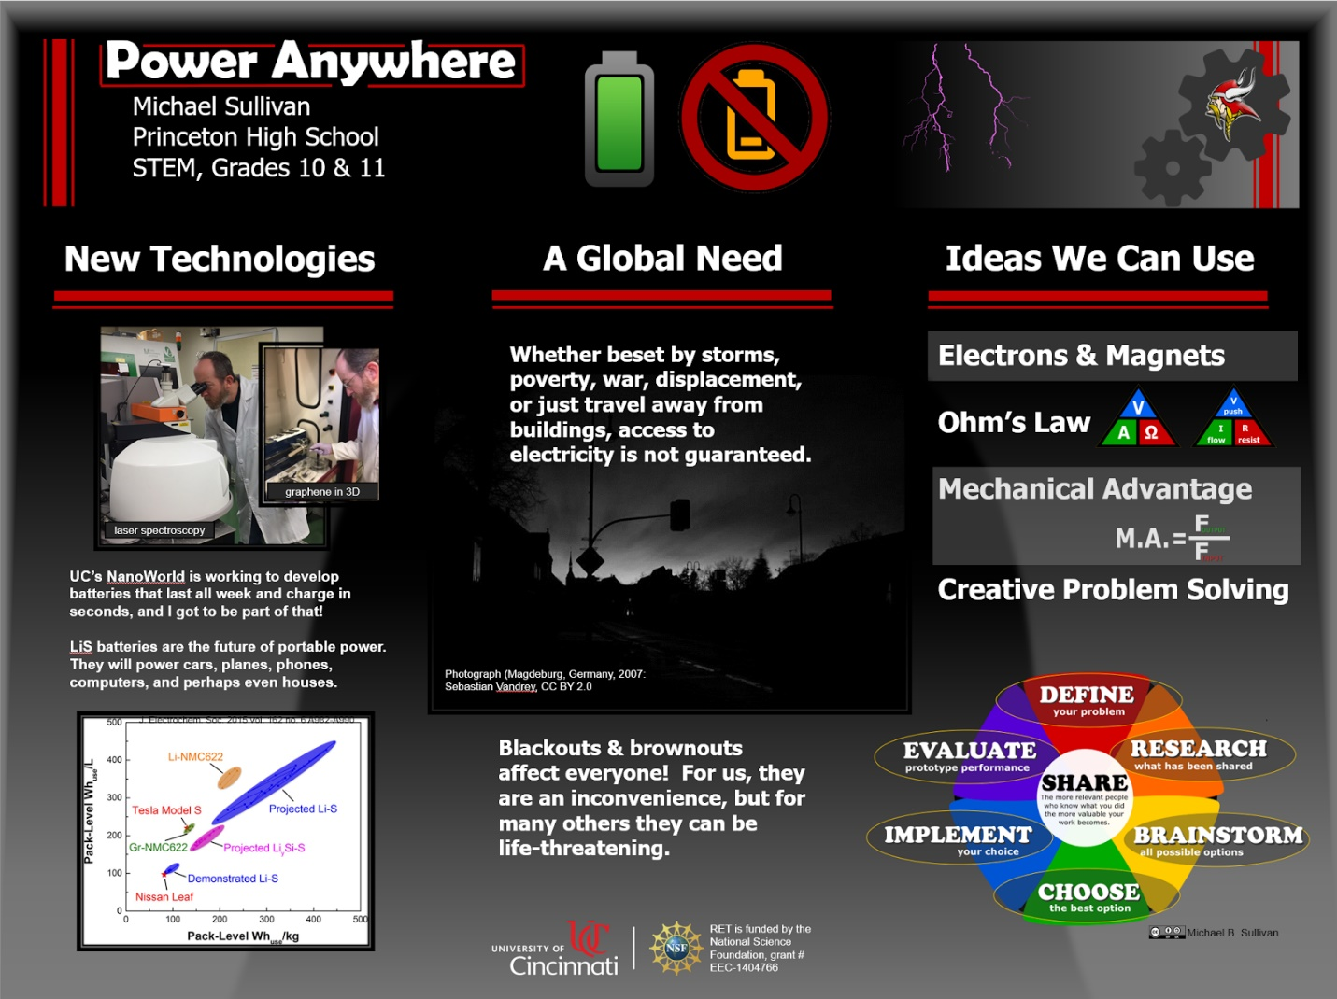
If you are a science teacher, check the boxes below that apply:
Next Generation Science Standards (NGSS)
Science and Engineering Practices (Check all that apply) | Crosscutting Concepts (Check all that apply)
☐ Asking questions (for science) and defining problems (for engineering) | ☐ Patterns
☐ Developing and using models | ☐ Cause and effect
☐ Planning and carrying out investigations | ☐ Scale, proportion, and quantity
☐ Analyzing and interpreting data | ☐ Systems and system models
☐ Using mathematics and computational thinking | ☐ Energy and matter: Flows, cycles, and conservation
☐ Constructing explanations (for science) and designing solutions (for engineering) | ☐ Structure and function.
☐ Engaging in argument from evidence | ☐ Stability and change.
☐ Obtaining, evaluating, and communicating information

If you are a science teacher, check the boxes below that apply:
Ohio’s Learning Standards for Science (OLS)
Expectations for Learning - Cognitive Demands (Check all that apply)
☐ Designing Technological/Engineering Solutions Using Science concepts (T)
☐ Demonstrating Science Knowledge (D)
☐ Interpreting and Communicating Science Concepts (C)
☐ Recalling Accurate Science (R)

If you are a math teacher, check the boxes below that apply:
Ohio’s Learning Standards for Math (OLS) or
Common Core State Standards -- Mathematics (CCSS)
Standards for Mathematical Practice (Check all that apply)
☐ Make sense of problems and persevere in solving them | ☐ Use appropriate tools strategically
☐ Reason abstractly and quantitatively | ☐ Attend to precision
☐ Construct viable arguments and critique the reasoning of others | ☐ Look for and make use of structure
☐ Model with mathematics | ☐ Look for and express regularity in repeated reasoning

Part 2: Post Implementation- Reflection on the Unit
Results: Evidence of Growth in Student Learning - After the Unit has been taught and the Post-Unit Assessment Instrument has been used to assess student growth in learning, the teacher must analyze the data and determine whether or not student growth in learning occurred. Present all documents used to collect and organize Post- Unit evaluation data such as graphs or charts. Provide a written analysis in sentence or paragraph form which provides the evidence that student growth in learning took place. Please present results and, if applicable, student work (as a hyperlink) used as evidence after the Unit has been taught.

Please include:
- Any documents used to collect and organize post unit evaluation data. (charts, graphs and /or tables etc.)
- An analysis of data used to measure growth in student learning providing evidence that student learning occurred. (Sentence or paragraph form.)
- Other forms of assessment that demonstrate evidence of learning.
- Anecdotal information from student feedback.

Reflection: Reflections: Reflect upon the successes of teaching in this Unit in 5 or more sentences in the form of a narrative. Consider the following questions:
- Why did you select this content for the Unit?
- Was the purpose for selecting the Unit met? If yes, provide student learning related evidence. If not, provide possible reasons.
- Did the students find a solution or solutions that resulted in concrete meaningful action for the Unit’s Challenge? Hyperlink examples of student solutions as evidence.
- What does the data indicate about growth in student learning?
- What would you change if you re-taught this Unit?
- Would you teach this Unit again? Why or why not?

